**Enhanced Security Monitoring for Western Mindanao State University using Facial Recognition and Neural Network**

**By**

**Ronald Dale A. Fuentebella**

**Josua Z. Habil**

**In Partial Fulfilment of the Requirements for**

**Bachelor of Science in Computer Science**

**May 2021**

Table of Contents

List of Tables 3

List of Figures 3

CHAPTER I 4

Background of the Project 4

Statement of the Problem 5

Objectives 5

Significance 6

Scope and Limitations 7

Conceptual Framework 7

Operational Definition 8

CHAPTER III 16

Research Design 17

Research Locale 17

Population and Sampling 17

Research Instrument 17

Validity of the Instrument 17

Data Gathering Procedure 17

**Image Acquisition** 18

**Face Detection** 18

**Face Extraction** 18

**Comparing faces** 19

Survey Questionnaire 20

Statistical Tool 20

REFERENCES 21

APPENDICES 22

Turnitin Plagiarism Report 22

Survey Questionnaire 23

Survey Result 24

# List of Tables

Table 1 15

# List of Figures

Figure 1 Conceptual Framework 15

Figure 2 Generating Vector 18

Figure 3 Similar Faces 18

Figure 4 Comparing Faces 19

# CHAPTER I

## **Background of the Project**

Numerous nations presently utilize public video surveillance cameras (CCTV's) as an essential tool to screen populace occurrences, developments, and prevention of crime and terrorism, both within the private and public sectors. As of 2021, according to Visual Capitalist article by Avery Koop, India's two cities Chennai and Hyderabad, are recorded to have the most CCTV's installed, Chennai with 657 CCTV's per square km and Hyderabad with 480 CCTV's per square km. Every year in India, tens of thousands of children go missing, and many are trafficked to work in eateries, handicraft industries, brick kilns, factories, or into begging and brothels. Due to these events, Chennai police authorities developed a facial recognition app, scanned 3,000 records, and were able to help them reunite half of the missing children with their families in January 2020.

In the Philippines, CCTVs are getting popular due to their effectiveness in monitoring crime and accident-related incidents. Populated cities like Makati, Metro Manila, Quezon, etc., are implementing CCTV as an essential tool to help law enforcement keep the peace, order and discipline the lawbreaker.

Facial recognition is a biometric software application capable of uniquely identifying or verifying a person by comparing and analyzing patterns based on the person's facial contours; According to Sunstar PH, "Zamboanga City's Security and Surveillance Coordinating Office (SSCO) Command Center was launched on May 6, 2019". It is a facility that serves as the center of all surveillance cameras installed all through the city. Its principal function is monitoring and crime prevention. It shows that CCTV cameras are the primary tool currently used nowadays to implement peace and order. Similarly, many schools in the city used the same method to monitor all activity happening on their school premises. Western Mindanao State University had CCTV cameras installed in different locations throughout the school. With the help of CCTV cameras, crime prevention and monitoring of the students are achieved effortlessly. Although it serves useful, CCTV cameras cannot do all the work necessary to identify individuals caught on cam. It is true for circumstances such as crime response personnel arriving at the scene late or individuals caught in the act escaping before response teams are dispatched. The purpose of this project is to fill in the CCTV's shortcomings; Today, universities and colleges are seeking technological innovation to re-open their campuses safely for the already started school year; This will be a challenge for everyone, that is why a solution is needed; with the system that is being proposed we are trying to provide a better way to monitor, identify and give better security to each and every student, teachers, and staff in the campus with hygienic, seamless and preferably touchless, high-assurance identity management.

The proposed system "Enhanced Security Through Facial Recognition with Neural Network" will bring new technology and upgrades to CCTV's and adding new capabilities.

This study aims to enhance and improve the security of Western Mindanao State University. The facial recognition technology is integrated on CCTV around the school campus and into the school attendance system to enhance security.

## **Statement of the Problem**

This project is established to improve Western Mindanao State University's security and upgrade the currently used attendance system of the school. For a large university, security personnel are not enough to secure the school premises; Therefore, the addition of a facial recognition system would be implemented for much better security.

## **Objectives**

This project's general objective is to develop a system that implements public security through the use of Facial Recognition in the Western Mindanao State University Campus. Specifically, this project sought to achieve the following objectives:

* Develop a facial recognition system that is capable of storing and recording the facial image with personal information of students, faculty, staff and other WMSU associates.
* To create a Facial Recognition system using OpenCV and dlib face recognition neural network library for better accuracy and performance.
* Aid the disciplinary officers of WMSU in monitoring and crime prevention.
* Identify the significance of having a facial recognition system as a tool for monitoring crimes and accidents around WMSU campus.
* To create a better attendance and log management system for the students, faculty and staff.

## **Significance**

This study is constructed to evaluate the effectiveness of instigating a facial recognition system at the Western Mindanao State University campus.

Benefitting this system are the various sectors as follows:

* Student - All students of WMSU are required to register their faces in the system. The registered faces will then be used to track the individual in and out time at the school campus.
* Employee - All employees of WMSU are required to register their faces in the system, for it will be used to track every individual's time in and time out on the school campus.
* WMSU Security Officers - The implementation of this system will be beneficial to security officers of WMSU, for it will be used in monitoring crime-related circumstances inside the school campus.
* Parents - The parents of the students will also benefit from the implementation of this system, for they will be assured that their children are safe. The WMSU management office can also use the data to inform parents if their child is attending school or not.
* Future researchers – The data and idea of the project may be used as a reference in developing new system related to computer vision and facial recognition; the data presented can also be used in testing the validity of related studies and serve as their cross-reference that will help them developed new innovative system.

## **Scope and Limitations**

The projects Scope are as follows:

* Administrator - Can log in into the system and do the following features; register face, search face, attendance and log management, remove a registered face from the system.
* Students, Faculty, and Staff - The students, faculty, and staff of WMSU must register their faces in the system and their names.

The projects limitations are as follows:

* Cannot scan individuals inside the cars or wearing helmets.
* The effectiveness of the system depends on the camera quality and the Computer's processing power. (Needs high-end techs).
* It can only be accessed offline.
* Cannot recognize unregistered individuals.

## **Conceptual Framework**

Figure 1 Conceptual Framework

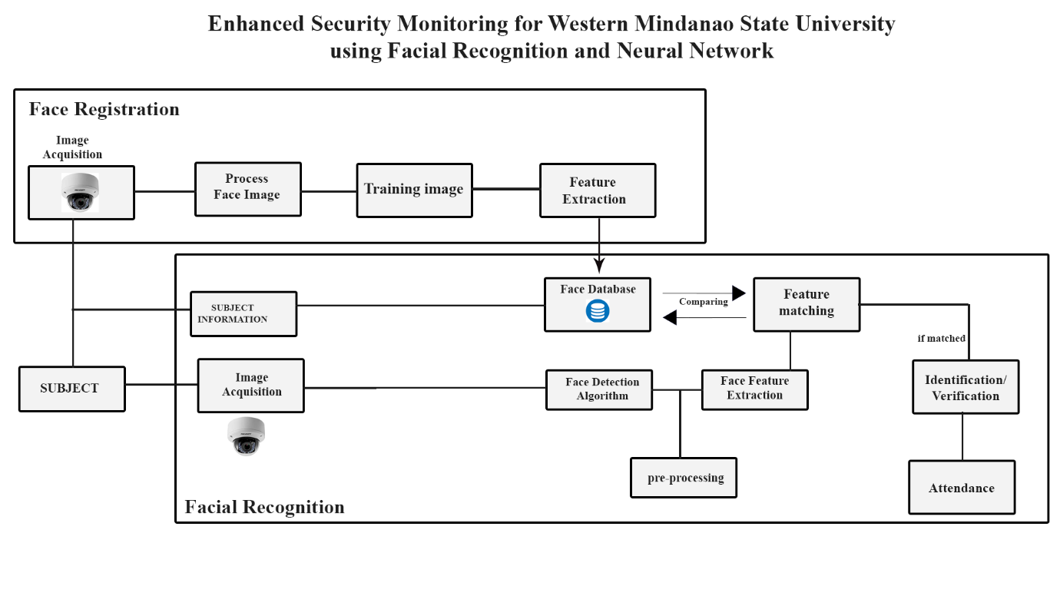

## **Operational Definition**

Table 1

|  |  |
| --- | --- |
| Facial Recognition | **A bio-metric software application capable of distinctively verifying or identifying a person by analyzing and comparing patterns based on the person's facial shapes is referred to as face recognition.** |
| Face Detection | **Face detection lets you find the location (pixel coordinates) of any faces in an image.** |
| Face Extraction | **A neural network takes an image of the person's face as input and outputs a vector that represents the essential features of a face.** |
| Image Acquisition | **Image Acquisition is the first stage of any vision system that refers to the collection of data required to form an image.** |
| Training image | **The training process involves finding a set of weights in the network that proves to be good, or good enough, at solving the specific problem.** |
| Face Database | **Database containing student and employee face** |
| Face embedding | Face embedding **is a vector that represents the features extracted from the face.** |
| Applied Research Design | **Refers to a type of research design that seeks to solve a specific problem or provide innovative solutions to issues affecting an individual, group or society.** |
| Descriptive-survey | This refers to a research design that uses surveys to gather data about varying subjects. |
| Stratified Random Sampling Method | This refers to a method of sampling that involves the division of a population into smaller sub-groups known as strata. |
| Frequency Table | Refers to a table that lists items and shows the number of times the item occurs. |

**CHAPTER II**

**REVIEW OF RELATED LITERATURES AND STUDIES**

The review of related literature is created to provide a summary of existing research or studies related to this project. This chapter contains the related literatures and related studies.

* 1. **Related Literature**

**2.1.1 CCTV**

CCTV's were first invented and used in Germany. It was a system developed to monitor the countries V-2 rockets. Until people realized its usefulness, it was launched commercially in 1949 for the public. Years have passed from the time it was invented, and CCTV's evolve into state-of-the-art equipment with several applications in many businesses and homes during this period.

According to Koorsen Fire & Security, CCTV is everywhere these days. You'll find them in pretty much every bank, school, hospital, and business of every size, even in many homes. Wherever you find them, they act as an extra eye for whenever people are not around. They are there to prevent crime, monitor the environment, and, most importantly, record video footage that may be important. What does CCTV mean, and How does it work? Closed Circuit Television (CCTV) or simply Video Surveillance Systems are unique cameras that people use to monitor security and other reasons. For the CCTV to work, it must have these four parts; cameras, recording devices, monitors, and video management software. (Koorsen Fire & Security , 2021)

Schools these days are also implementing the use of CCTV to benefit from its usefulness, whether campus security, attendance system, automated registration, and emotion detection.

**2.1.2 Facial Recognition**

According to a study by Parekh Payal and Mahesh M. Goyani, Face Recognition identifies and verifies faces. Face recognition has vast importance in Security, Healthcare, Banking, Criminal Identification, Payment, and Advertising. The study determines various challenges and techniques for face recognition. Challenges such as illumination, pose variation, facial expressions, occlusions, aging, etc., are the critical challenges to face recognition. The methods used for facial recognition to work are pre-processing, Face Detection, Feature Extraction, Optimal Feature Selection, and Classification are the primary steps in any face recognition system. The study also states that facial extraction is the most crucial stage for any facial recognition system to work and the deep learning method helps the user by freeing them from handcrafting the features. (Payal & Goyani, 2020)

Another study by Serign Modou Bah and Fang Ming states that a lot of development has been made in the area of facial recognition and detection for security, identification, and attendance purposes. Still, it turns out that there are still issues that hinder progress from reaching or surpassing human-level accuracy. These issues are varieties in human facial appearance such as; changing lighting condition, clamor in confront pictures, scale, posture, etc. With these challenges to consider, the researchers of this study used another method by using Local Binary Pattern (LBP) algorithm combined with advanced image processing techniques such as Contrast Adjustment, Bilateral Filter, Histogram Equalization, and Image Blending. These solve some of the issues hampering face recognition accuracy to improve the LBP codes, thus improve the accuracy of the overall face recognition system. (Serign & Ming, 2019)

**2.1.3 Neural Network**

In a research done by Naoyuki Kubota (2011) titled “ Applying Artificial Neural Networks for Face Recognition” in the process of identifying or analyzing the facial land points the researcher used hybrid model combining AdaBoost and Artificial Neural Network (ABANN) to improve the efficiency of facial recognition; the system consist of four modules : detection, alignment, feature extraction, and matching ; The research done by Naoyuki Kabuto provides some basic neural network models and efficiently applies these models in modules of face recognition system. For face detection module, a three-layer feedforward artificial neural network with Tanh activation function is proposed that combines AdaBoost to detect human faces so that face detecting rate is rather high. (Kubota, 2011)

The Naoyuki Kubota facial recognition with neural network basically uses three-layer feedforward artificial neural network and AdaBoost for detecting human faces which in comparison with traditional technique shows higher identifying and detecting rate.

While in a research done by Juan Pablo Balarini, Sergio Nesmachnow and Martín Rodríguez of Universidad de la República, Facultad de Ingeniería titled “ Facial Recognition Using Neural Networks over GPGPU” they introduce the use of parallel neural network approach which also use the processing power of Graphic Processing Unit (GPU); in their studies the three researcher thought that the efficiency of Neural network processing image in detecting facial points would be effective and efficient with the help of GPU which they stated that “GPU implementations allow obtaining significant reduction in the execution times of complex problems when compared with traditional sequential implementations on CPU” and with the use of sequential algorithm by Shufelt and Mitchell for recognizing if a given picture is of a certain person. (Balarini, Nesmachnow, & Rodríguez, 2012)

The method of Naoyuki Kubota slightly improve the analyzing process with the use of hybrid model and combing AdaBoost and Artificial Neural Network for detecting and matching face; but in the test experiments in prove that AdaBoost and ANN approaches for detecting faces do not achieve good results of performance time and detecting rate yet;

While the research done by Juan Pablo Balarini, Sergio Nesmachnow and Martín Rodríguez of Universidad de la República have much better outcome with significant reduction on computing times can be obtained allowing solving large instances in reasonable time. Speedup greater than 8 is achieved when contrasted with a sequential implementation and classification rate superior to 85 % is also obtained.

**2.1.4 Deep Learning**

Deep Learning is a subfield of Machine Learning which uses a ‘layered’ architecture to learn representations. Each successive layer in the layered architecture works with more meaningful and sophisticated representations; in a research done by Diego Andina (2017) titled “Deep Learning for Computer Vision” he talks about how deep learning evolve in short span of time according to Diego Andina “Deep learning methods have been shown to outperform previous state-of-the-art machine learning techniques in several fields, with computer vision being one of the most prominent cases” which is correct from unlocking your smartphone to facebook improve tagging system; deep learning really evolve on how computer interpret and analyzing data, in his research he stated that Deep learning allows computational models of multiple processing layers to learn and represent data with multiple levels of abstraction mimicking how the brain perceives and understands multimodal information. (Andina, 2018)

The researcher Diego Andina also indicates that there are 4 most significant deep learning schemes used in computer vision problems, that is, Convolutional Neural Networks, Deep Boltzmann Machines and Deep Belief Networks, and Stacked Denoising Autoencoders which can be used for system like object detection, face recognition, action and activity recognition, and human pose estimation.

In a research done by Md Nazmus Saadat and Muhammad Shuaib (2020) titled “ Advancements in Deep Learning Theory and Applications: Perspective in 2020 and beyond “ the researcher talk how deep learning works; the researcher stated that there are two types of machine learning ; first is the supervised learning, the machine can only give you correct output when the input is already experienced in training phase; it is based on experience; the more is the training dataset or experience of your machine the higher is the chances of getting the actual output, and the second is unsupervised learning, supervision of a model is not needed, rather the model work on its own catches new data and discovers the information inside the data. It usually deals with label-less data; compared to supervised learning, unsupervised learning is more complicated. It is usually used to find features and unknown patterns. (Saadat & Shuaib, 2020)

* 1. **Foreign Studies**

**2.2.1 Motion Detection and Face Recognition for CCTV Surveillance System**

According to this study development of the use of CCTV has transformed from a simple passive surveillance into an integrated intelligent control system. This CCTV video processing provides three outputs, a motion detection information, a face detection information and a face identification information. Accumulative Differences Images (ADI) used for motion detection, and Haar Classifiers Cascade used for facial segmentation. Feature extraction is done with Speeded-Up Robust Features (SURF) and Principal Component Analysis (PCA). The features was trained by Counter-Propagation Network (CPN). Offline tests performed on 45 CCTV video. The test results obtained a motion detection success rate of 92,655%, a face detection success rate of 76%, and a face detection success rate of 60%. The results concluded that the process of faces identification through CCTV video with natural background have not been able to obtain optimal results. The motion detection process is ideal to be applied to real-time conditions. But in combination with face recognition process, there is a significant delay time. (Nurhopipah & Harjoko, 2018)

**2.2.2 Face Recognition-based Real-time System For Surveillance**

According to this research paper the ability to automatically recognize human faces based on dynamic facial images is important in security, surveillance and the health/independent living domains. Specific applications include access control to secure environments, identification of individuals at a particular place and intruder detection. This research proposes a real-time system for surveillance using cameras. The process is broken into two steps: (1) face detection and (2) face recognition to identify particular persons. For the first step, the system tracks and selects the faces of the detected persons. An efficient recognition algorithm is then used to recognize detected faces with a known database. The proposed approach exploits the Viola-Jones method for face detection, the Kanade-Lucas-Tomasi algorithm as a feature tracker and Principal Component Analysis (PCA) for face recognition. This system can be implemented at different restricted areas, such as at the office or house of a suspicious person or at the entrance of a sensitive installation. The system works almost perfectly under reasonable lighting conditions and image depths. (Fahad , Habib, Vasant, Mckeever, & Ahad, 2016)

This research paper is related to our study for it tackled the use of CCTV in implementing facial recognition systems at different restricted facilities, such as workplaces, houses, and schools. The study also aims to use the system for crime monitoring and prevention and detection of suspicious individuals, which is the same objective that our research has.

* 1. **Local Studies**

**2.3.1Student Monitoring System Of Our Lady Of Fatima University Using Face Recognition**

This research paper concludes that the rapid development of face recognition is due to a combination of factors: active development of algorithms, the availability of large databases of facial images, and a method for evaluating the performance of face recognition algorithms. The system covers any departments, agencies or companies which require personal identification and security to their employees. The face recognition system covers multiple face photos, matching of faces, head rotations, detects 66 facial feature points (eyes, eyebrows, mouth and nose) and all data are placed in a database. Additional enrolments will be required upon various changes in registered faces. The said system only limits to personal identification which contains certain fields about the registered user, it cannot detect the skin color and age of a person and the system is not a video- based face recognition system. This system does not expect to solve all the issues in face recognition, such as extreme facial expression, wearing on the face, great age discrepancy and extreme lightning condition and without frontal face information. (Alolor, et al., 2014)

**2.3.2 Deep Learning**

Deep learning technologies include facial recognition, optical character recognition that could automatically read documents, natural language processing and voice recognition; in an article by Noemi Lardizabal-Dado of Manila Times she stated that “Artificial intelligence (AI) will be more than just talk in 2020” I fully agree to this sentence; in the midst of covid-19 we must take advantage of latest technology to solve problems like in security, education and healthcare; AI technology could help the Philippines bounce back from the coronavirus disease 2019, the article by Neomi Lardizabal-Dabo mainly talks about Deep learning technologies include facial recognition, optical character recognition that could automatically read documents, natural language processing and voice recognition.

We’ve seen how e-commerce and food delivery industries are essential services during this pandemic. But what happens when lockdowns mean e-commerce platforms could not physically meet and onboard new suppliers or restaurants? The researcher said that AI could help retail and e-commerce players recover by facilitating contactless payments, digital onboarding of new customers or suppliers, preventing fraud or fake accounts when ordering/paying, logistics and inventory management. The list goes on.

AI can help sort and categorize relevant health data on millions of patients in the Philippines into a single unified view. This can then be used across airlines, immigration, work permits, embassies, hospitals and even travel insurance industries without a lot of manual paperwork required.

# ****CHAPTER III****

## **Research Design**

The study will be using the Applied research design method. The method is chosen to determine the respondents' perception in implementing the facial recognition system around the school campus of Western Mindanao State University.

## **Research Locale**

           The research study is conducted at Western Mindanao State University's main campus, where students and employees will be the respondents. The Western Mindanao State University main campus is located at Normal Rd, Zamboanga City, Zamboanga Del Sur.

## **Population and Sampling**

           The researchers will use the Stratified Random Sampling Method to stratify the WMSU population by the college. The researchers will only gather sample sizes from 5 colleges of WMSU. In each college, the researchers will obtain equal measures of respondents.

           The participation of WMSU employees is essential in collecting data for the study; therefore, the researchers will also obtain respondents from WMSU's faculty and staff.

## **Research Instrument**

The researchers will be using a survey questionnaire to gather data from the respondents. The survey questionnaires will be consisting two parts. Part 1 of the research instrument collects personal information from the respondents, such as name, age, gender, and college. Part 2 of the research instrument contains a questionnaire where the research gathers the necessary data to complete the study.

## **Validity of the Instrument**

**The researchers produce a self-made survey questionnaire in which the ideas are based on the previously cited related studies. The researchers made sure that each item from the questionnaire is not biased and or fabricated. Therefore, validation from the research instructor is asked for approval of the survey questionnaire.**

## **Data Gathering Procedure**

### **Image Acquisition**

**The Face Recognition system will obtain the images by interfacing a CCTV or a webcam with an automation light sensor; the camera will be connected to the Computer.**

### **Face Detection**

**After capturing the image, the system will detect the person's face and proceed to the pre-processing phase by removing noise, enhance its contrast, cropping the image and resizing to standardize the data set.**

### **Face Extraction**

**Now that the image has passed the processing phase, the system will now extract features from it; using face embedding to extract the facial land points out of the face, the neural network takes the person's face as input and output a vector which will represent as the most important feature of a face;**

Figure 2 Generating Vector

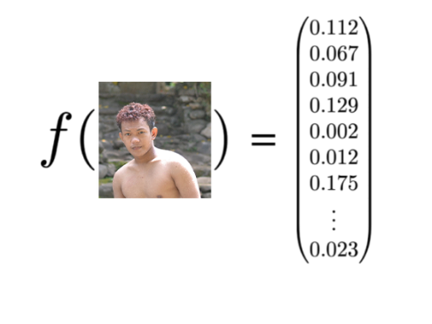

**After extracting, the system will use a face recognition library by Adam Geitgay with a pre-trained network trained by Davis King with a dataset of ~3 million images. The network will output a vector containing 128 numbers, which will be used as an ID to represent the feature of a person's face.**

**With this, the network can also learn to output similar vectors for faces that look similar, example, if the subject or person has multiple images of faces within the database with minor changes of faces features like beard, the model can still recognize if they are very close in the vector space.**

Figure 3 Similar faces

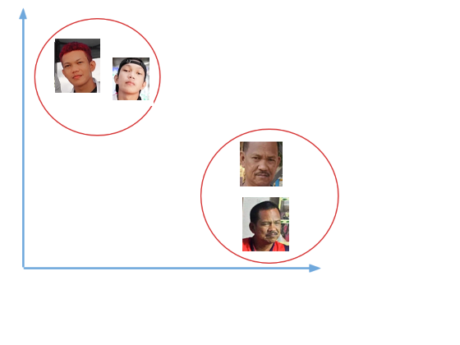

### **Comparing faces**

**After generating a vector, they represent the person's face and saving it to the database; the next phase is to compare the faces in the camera video feed from the faces in the database. The first step in this process is to also compute and generate the face embedding for the face's obtain in the camera using the same network that the system uses to train the image and compare this embedding with the rest of the face embedding we have in the database; the system will recognize the face if the generated embedding is equal or closer to other face embedding in the database.**

Figure 4 Comparing Faces

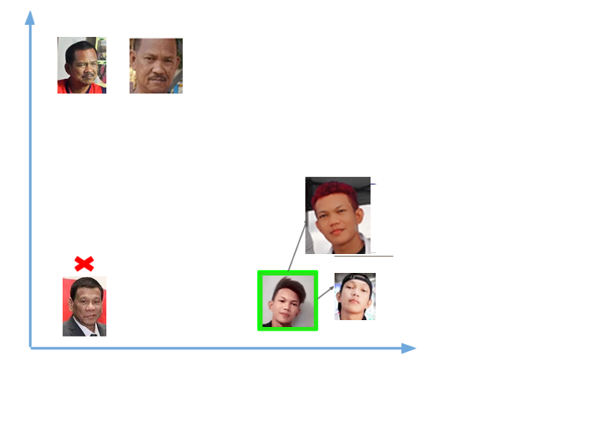

## **Survey Questionnaire**

In this study, the researchers used a survey questionnaire. The questions are based on the cited related studies (see Review of Related Literature) and were approved by the research instructor/s.

           During the data gathering process, the researchers distribute each respondent a survey questionnaire online. The gathered data were then tallied and graphed for data analysis.

           The researchers used the data gathered to attain the respondents' ideas, knowledge, and feedback in implementing a facial recognition system to support the study.

## **Statistical Tool**

The following statistical tools were utilized to analyze gathered data: the researchers used the frequency table for the survey, which is a statistical tool under the qualitative research method. The frequency table consists of bar charts and pie charts representing the data gathered from the respondents. Stratified random sampling is used to acquire the sample size of the study; The researcher also uses Python NumPy, a core library for scientific computing in Python. It provides a high-performance multidimensional array object and tools for working with these arrays; this will allow us to compute and returns indices of the min element of the array in a particular axis of the face distance.

# 

# REFERENCES

1. Andina, D. (2018, February 1). *Computational Intelligince and Neuroscience.* Retrieved from www.hindawi.com: https://www.hindawi.com/journals/cin/2018/7068349/
2. Balarini, J., Nesmachnow, S., & Rodríguez, M. (2012). *CLEI Electronic Journal.* Retrieved from http://www.scielo.edu.uy/: http://www.scielo.edu.uy/scielo.php?script=sci_arttext&pid=S0717-50002012000300007
3. Fahad , M. P., Habib, M., Vasant, P., Mckeever, S., & Ahad, M. R. (2016, September). *Face recognition-based real-time system for surveillance.* Retrieved from www.researchgate.net: https://www.researchgate.net/publication/308387275_Face_recognition-based_real-time_system_for_surveillance
4. *Koorsen Fire & Security .* (2021, March 05). Retrieved from blog.koorsen.com: https://blog.koorsen.com/the-evolution-of-cctv-systems-in-commercial-security
5. Kubota, N. (2011, November 3). *Advances in artificial Neural Systems.* Retrieved from www.hindawi.com: https://www.hindawi.com/journals/aans/2011/673016/
6. Payal, P., & Goyani, M. M. (2020, March 27). *Taylor & Francis Online.* Retrieved from www.tandfonline.com: A comprehensive study on face recognition: methods and challenges: The Imaging Science Journal: Vol 68, No 2 (tandfonline.com)
7. Saadat , N., & Shuaib, M. (2020, December 9). *Advancements in Deep Learning Theory and Applications: Perspective in 2020 and beyond.* Retrieved from www.intechopen.com: https://www.intechopen.com/books/advances-and-applications-in-deep-learning/advancements-in-deep-learning-theory-and-applications-perspective-in-2020-and-beyond
8. Serign , B. M., & Ming, F. (2019, December 26). *ScienceDirect.* Retrieved from www.sciencedirect.com: https://www.sciencedirect.com/science/article/pii/S2590005619300141

# APPENDICES

## **Turnitin Plagiarism Report**

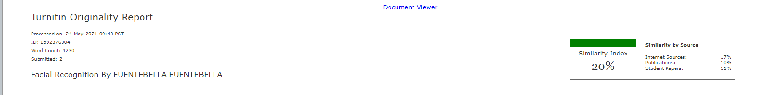



## **Survey Questionnaire**

Enhanced Security Monitoring for Western Mindanao State University using Facial Recognition and Neural Network

We would like to know what you think about implementing a facial recognition system around the school campus of Western Mindanao State University, so we hope that you answer the following questions truthfully and based on your own opinion. All responses will remain confidential and anonymous. Thank you for your time!

_________________________________________________________________________

Name:

Age:

Gender:

Year & Section:

___________________________________________________________________________

1. If Western Mindanao State University implements a facial recognition attendance system on the main campus gate, would you agree with it? *

YES

NO

1. Will you feel safe if there is a facial recognition system on the school campus? *

YES

NO

1. Are you willing to register your face in the system for security purposes? *

YES

NO

1. Would you agree if a facial recognition system is implemented as a way of checking attendance? *

YES

NO

1. Would you prefer Facial Recognition for attendance over RFID?

YES

NO

1. Do you think implementing facial recognition in school gates is a convenient alternative? *

YES

NO

1. What are your thoughts about the facial recognition system?

## **Survey Result**

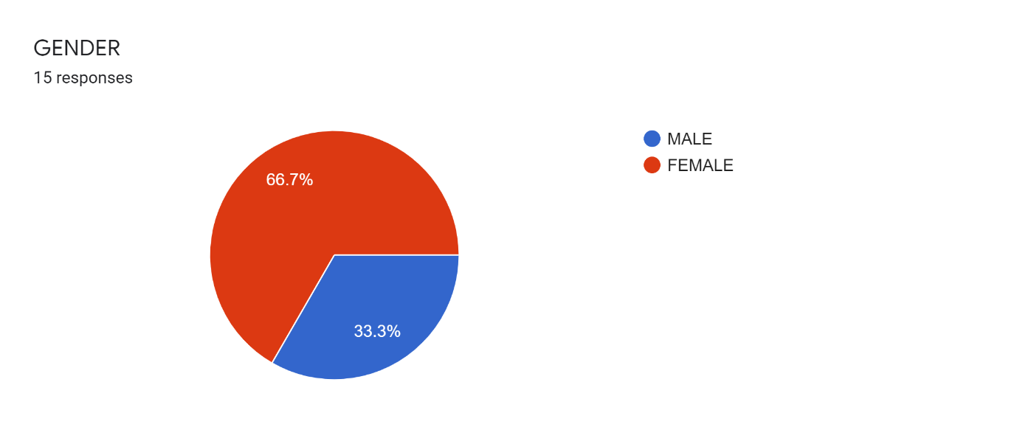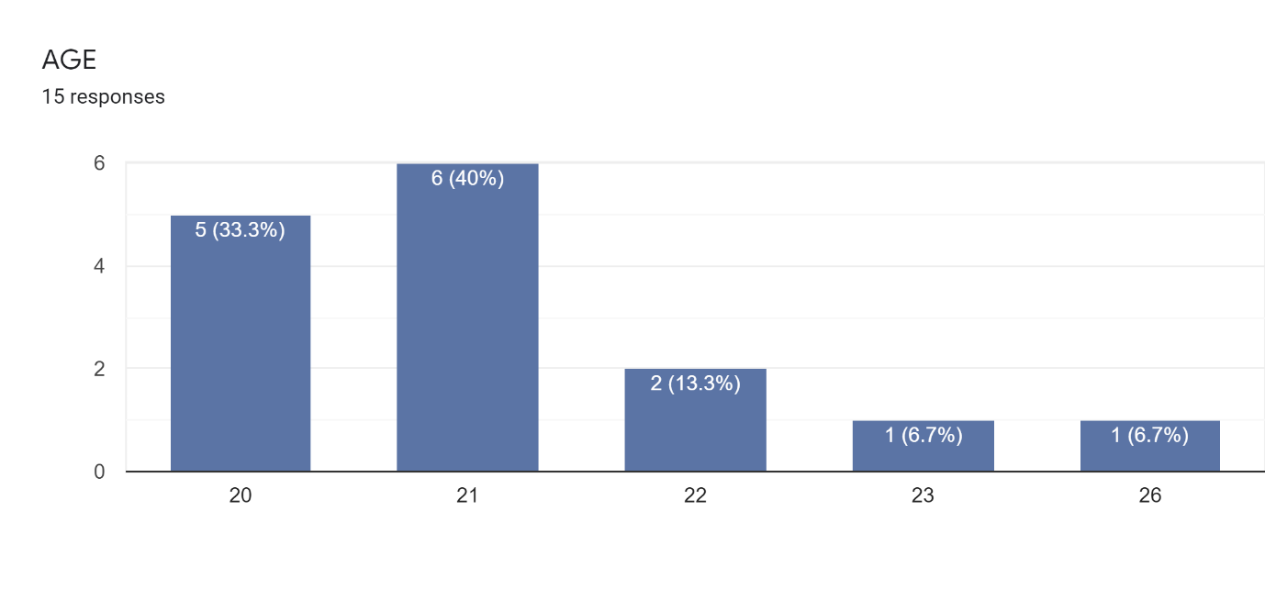

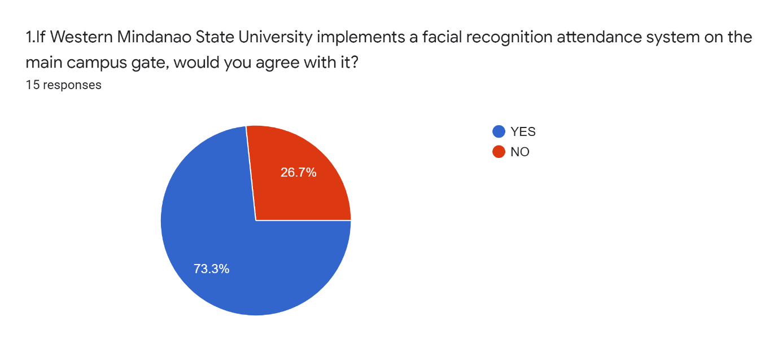

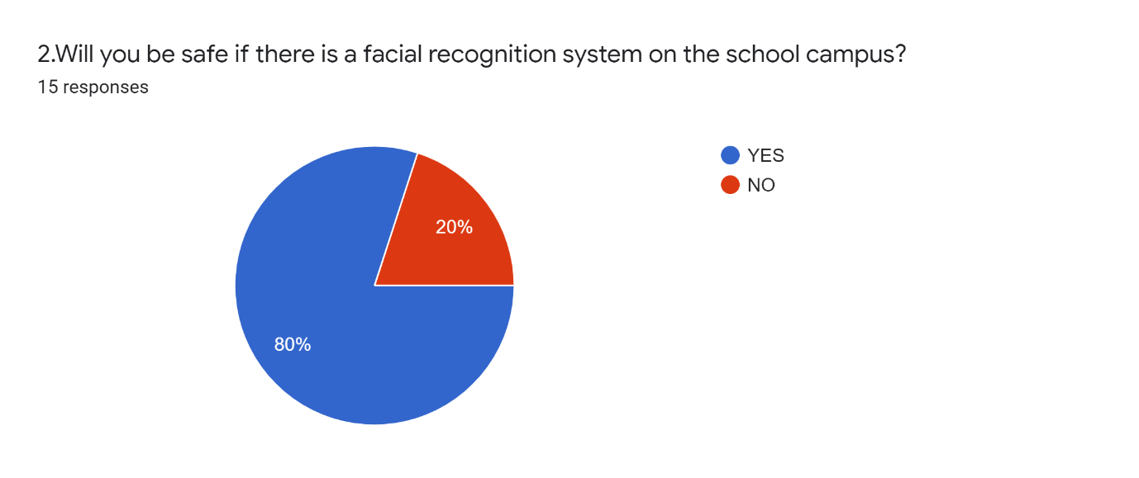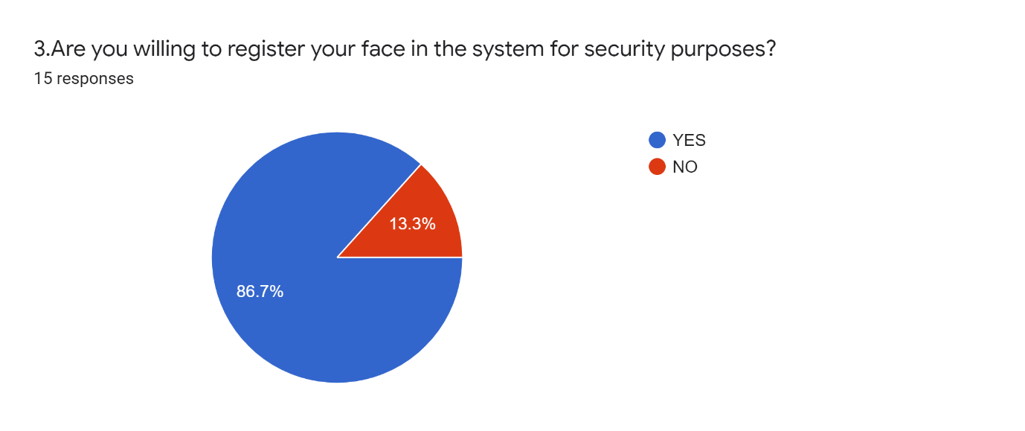

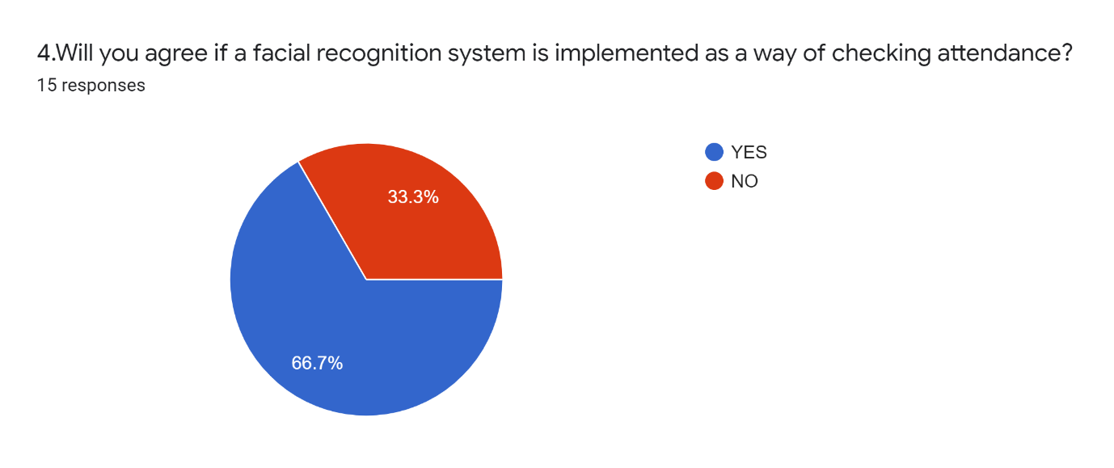

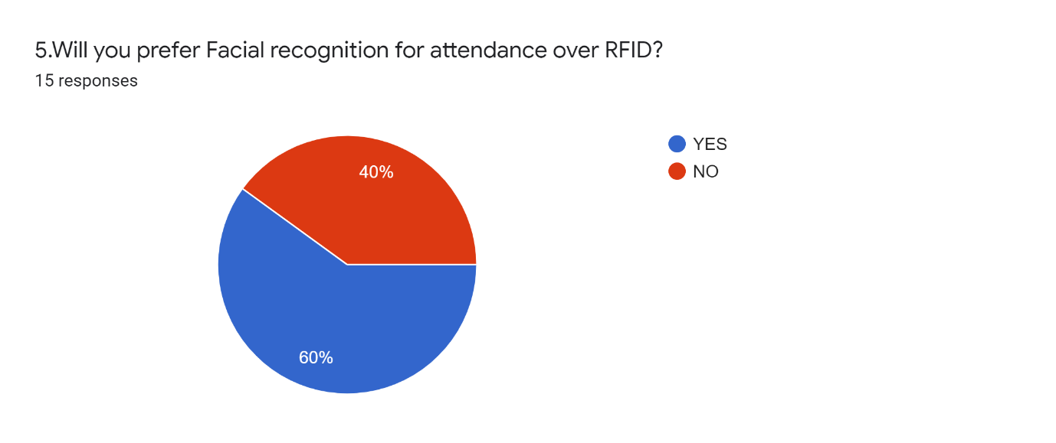

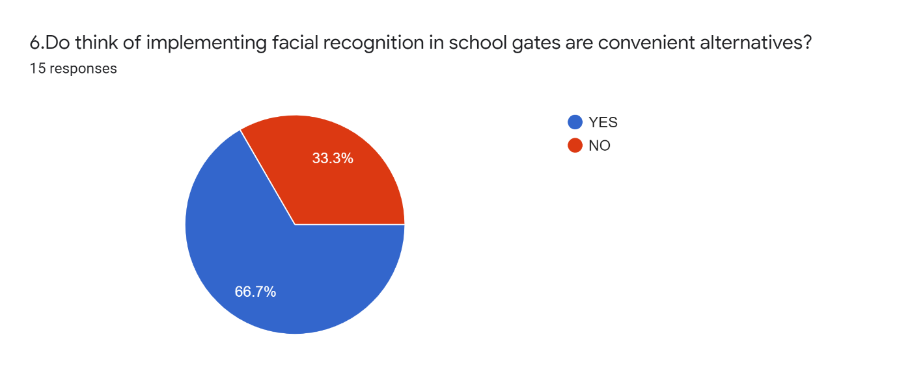

1. What are your thoughts about the facial recognition system?

15 responses

|  |
| --- |
| If it's accurately working on, it's fine. |
| I think I need some time to think about it. |
| It's new to me, and it's a good idea this will help maintain the security inside the campus to avoid unnecessary things |
| Implementing facial recognition is a nice idea. So that outsider student, you can easily enter our school campus. |
| Very nice, Initiative |
| I think implementing a facial recognition system on the school campus is a very helpful way to maximize the safety and security of all students and staff at the university. |
| It's good. |
| Good |
| Secured, convenient and hustle-free |
| Facial recognition gives us convenience. |
| I think the idea of implementing a facial recognition system in our school as a way for security purposes is one of the great ideas. However, I believe this will cause some inconvenience and perhaps a glitch if it will be put in our school gate, thus a good idea as an alternative for checking the attendance of the students. |
| My thoughts about the facial recognition system are, there is a way for students to avoid absence in schools and for security purposes; although it can be a hassle for students entering the campus, I will prefer this kind of attendance. |
| For security purposes. |
| Although it has seemed secured, it can easily be breached. Facial recognition technology is not the not secured medium, be it's for security or for convenience purposes. For example, if I don't wanna go to school on a particular day, a friend of mine can just bring a photo of me to check for my attendance. With the help of other techs like infrared cameras to determine a face belongs to someone alive or not, facial recognition for attendance checking is not a great alternative. Instead, another biometric security is far from as fingerprint scans or of the university is rich, a retina scan. Then we can all feel like James Bond. |